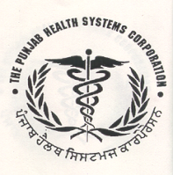
Punjab Health Systems Corporation
State Institute of Health and Family Welfare Complex Adjoining Civil Hospital Phase VI, Ajit Garh (Mohali),
: 0172-2266938 Fax: 2266938,  E-mail: eewmohali@gmail.com

NO: SPL-1 Dated: 19/02/2018
Corrigendum
Refer to Invitation Quotation Notice No.01, dated 17.01.2018, due to administrative reasons the dates for submission and opening has been changed as below:-
S.No | Description | Important Dates/Time | Now Read Important Dates/Time
I) | Sale of quotation Document upto | 20/02/2018 upto 11:30 hrs | 07/03/2018 upto 11:30 hrs
ii) | Submission of Quotation | 20/02/2018 upto 12:00 hrs | 07/03/2018 upto 12:00 hrs
iii) | Technical Opening | 21/02/2018 at 11.00 hrs | 08/03/2018 at 11.00 hrs

Rest Terms and Conditions remain same
SD/-
Executive Engineer (W)
For Managing Director

